Java Programming

Name: Om Ashish Mishra

Registration Number: 16BC E0789

Slot: G2

1. Design a GUI application using JavaFX classes to convert the temperature in Celsius to Fahrenheit and vice versa.

[ Hint: Use the following UI design as a reference.]

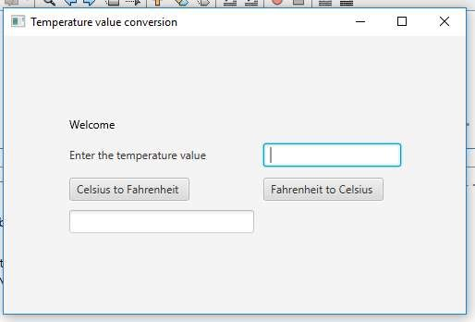

Answer:

The Code:

/*

* To change this license header, choose License Headers in Project Properties.

* To change this template file, choose Tools | Templates

* and open the template in the editor.

*/

package pkg16bce0789_3;

/**

*

* @author OM MISHRA

*/

//package frames;

import javafx.geometry.Insets;

import javafx.application.Application;

import javafx.event.ActionEvent;

import javafx.event.EventHandler;

import javafx.geometry.Pos;

import javafx.scene.Scene;

import javafx.scene.control.Button;

import javafx.scene.control.Label;

import javafx.scene.control.TextField;

import javafx.scene.layout.GridPane;

import javafx.scene.text.Text;

import javafx.stage.Stage;

public class Main extends Application{

public static void main(String[] args) {

launch(args);

}

@Override

public void start(Stage primaryStage) {

primaryStage.setTitle("Temperature value conversion");

GridPane grid = new GridPane();

grid.setAlignment(Pos.CENTER);

grid.setHgap(10);

grid.setVgap(10);

grid.setPadding(new Insets(25, 25, 25, 25));

Text scenetitle = new Text("Welcome");

Label promt = new Label("Enter the temperature value");

promt.setPrefSize(200, 30);

TextField tempVal = new TextField();

String temp = String.ValueOf(tempVal);

Button btn1 = new Button("Celsius to Fahrenheit ");

Button btn2 = new Button("Fahrenheit to Celsius ");

TextField res = new TextField();

grid.add(scenetitle, 0, 0);

grid.add(promt, 0, 1);

grid.add(tempVal,1, 1);

grid.add(btn1, 0, 2);

grid.add(btn2, 1, 2);

grid.add(res, 0, 3);

String s1 = btn1.temp;

double c = Double.parseDouble(s1);

double f = c*(9/5)+32;

String result = String.valueOf(f);

res = new TextField(result);

String s2 = btn2.temp;

double f = Double.parseDouble(s2);

double c = (f - 32)*(5/9);

String result = String.valueOf(f);

res = new TextField(result);

Scene scene = new Scene(grid, 500, 300);

primaryStage.setScene(scene);

primaryStage.show();

}

The Output:

On clicking Celsius to Fahrenheit:-

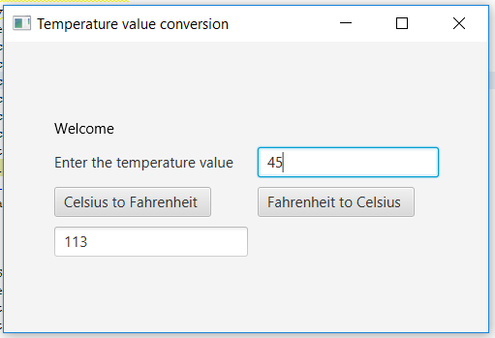

On clicking Fahrenheit to Celsius

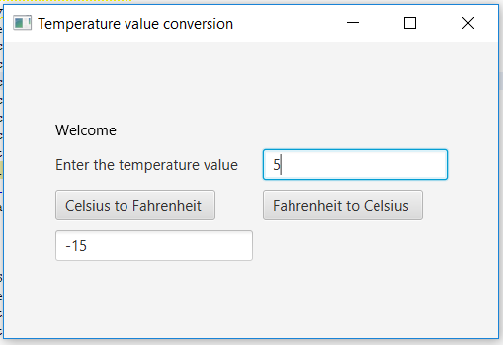

1. Design a GUI application using JavaFX classes to change the background color of the application using RadioButton class objects and to change the text appearance by using CheckBox class objects. Use two pane layout for each operation.

[ Hint: Use the following UI design as a reference.]

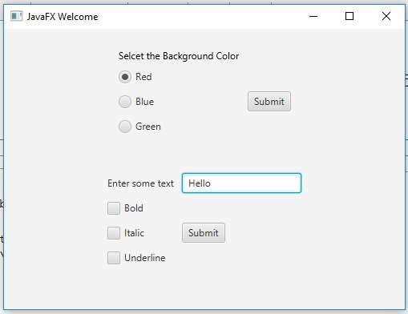

The Code:

package pkg16bce0789_3;

/**

*

* @author OM MISHRA

*/

import javafx.geometry.Insets;

import javafx.application.Application;

import javafx.event.ActionEvent;

import javafx.event.EventHandler;

import javafx.geometry.Pos;

import javafx.scene.Scene;

import javafx.scene.control.Button;

import javafx.scene.control.Label;

import javafx.scene.control.TextField;

import javafx.scene.layout.GridPane;

import javafx.scene.text.Text;

import javafx.stage.Stage;

import javafx.application.Application;

import javafx.scene.Scene;

import javafx.scene.control.RadioButton;

import javafx.scene.layout.HBox;

import javafx.stage.Stage;

import javafx.application.Application;

import javafx.scene.Scene;

import javafx.scene.control.CheckBox;

import javafx.scene.layout.HBox;

import javafx.stage.Stage;

public class Main extends Application {

@Override

public void start(Stage primaryStage) throws Exception {

primaryStage.setTitle("Welcome JavaFX");

Label promt = new Label("Select the Backgroud Colour");

RadioButton radioButton1 = new RadioButton("Red");

RadioButton radioButton2 = new RadioButton("Blue");

RadioButton radioButton3 = new RadioButton("Green");

RadioButton radioButton4 = new RadioButton("Yellow");

Button button = new Button("Submit");

Label promt1 = new Label("Enter the some text");

promt.setPrefSize(200, 30);

TextField tex = new TextField();

CheckBox ch1 = new CheckBox("Bold");

CheckBox ch2 = new CheckBox("Italics");

CheckBox ch3 = new CheckBox("Underline");

Button button1 = new Button("Submit");

HBox hbox = new HBox(promt,radioButton1, radioButton2, radioButton3, radioButton4,button,promt1,tex,ch1,ch2,ch3,button1);

Scene scene = new Scene(hbox, 1200, 500);

primaryStage.setScene(scene);

primaryStage.show();

}

public static void main(String[] args) {

Application.launch(args);

}

}

The Output:

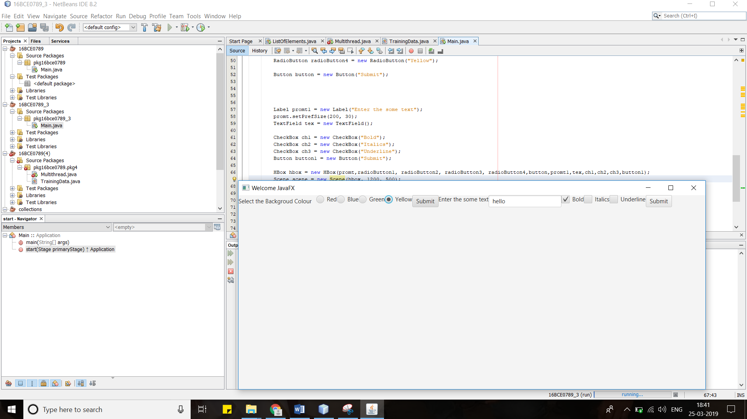

**hello**

1. Design a menu driven GUI application using JavaFX classes to perform arithmetic and string operations such as,
   1. Numerical data
      1. Addition
      2. Subtraction
      3. Multiplication
      4. Division
   2. String
      1. Finding length
      2. Copying a string
      3. Concatenating two strings
      4. Comparing two strings

[ Hint: Dialog boxes can be used wherever needed]

The Answer:

The code:

package pkg16bce0789_3;

/**

*

* @author OM MISHRA

*/

//package frames;

import javafx.geometry.Insets;

import javafx.application.Application;

import javafx.event.ActionEvent;

import javafx.event.EventHandler;

import javafx.geometry.Pos;

import javafx.scene.Scene;

import javafx.scene.control.Button;

import javafx.scene.control.Label;

import javafx.scene.control.TextField;

import javafx.scene.layout.GridPane;

import javafx.scene.text.Text;

import javafx.stage.Stage;

import javafx.application.Application;

import javafx.scene.Scene;

import javafx.scene.control.RadioButton;

import javafx.scene.control.ToggleGroup;

import javafx.scene.layout.HBox;

import javafx.stage.Stage;

package frames;

import java.util.Optional;

import javafx.application.Application;

import javafx.application.Platform;

import javafx.scene.Scene;

import javafx.scene.control.Alert;

import javafx.scene.control.Alert.AlertType;

import javafx.scene.control.Menu;

import javafx.scene.control.MenuBar;

import javafx.scene.control.MenuItem;

import javafx.scene.control.SeparatorMenuItem;

import javafx.scene.control.TextInputDialog;

import javafx.scene.layout.BorderPane;

import javafx.scene.paint.Color;

import javafx.stage.Stage;

public class Main extends Application{

void onadd()

{

//Reading first input for addition

TextInputDialog ip1 = new TextInputDialog();

ip1.setHeaderText("Give your input....");

ip1.setContentText("Enter an integer ");

Optional<String> val1 = ip1.showAndWait();

//Reading second input for addition

TextInputDialog ip2 = new TextInputDialog();

ip2.setHeaderText("Give your input....");

ip2.setContentText("Enter an integer ");

Optional<String> val2 = ip2.showAndWait();

//Converting string to int

int i1=Integer.parseInt(val1.get());

int i2=Integer.parseInt(val2.get());

//Displaying sum

Alert alert = new Alert(AlertType.INFORMATION);

alert.setHeaderText("The result is...");

alert.setContentText("Sum of the inputs is "+(i1+i2));

alert.showAndWait();

}

void onsub()

{

//Reading first input for difference

TextInputDialog ip1 = new TextInputDialog();

ip1.setHeaderText("Give your input....");

ip1.setContentText("Enter an integer ");

Optional<String> val1 = ip1.showAndWait();

//Reading second input for difference

TextInputDialog ip2 = new TextInputDialog();

ip2.setHeaderText("Give your input....");

ip2.setContentText("Enter an integer ");

Optional<String> val2 = ip2.showAndWait();

//Converting string to int

int i1=Integer.parseInt(val1.get());

int i2=Integer.parseInt(val2.get());

//Displaying diff

Alert alert = new Alert(AlertType.INFORMATION);

alert.setHeaderText("The result is...");

alert.setContentText("Difference of the inputs is "+(i1-i2));

alert.showAndWait();

}

void onmul()

{

//Reading first input for multiplication

TextInputDialog ip1 = new TextInputDialog();

ip1.setHeaderText("Give your input....");

ip1.setContentText("Enter an integer ");

Optional<String> val1 = ip1.showAndWait();

//Reading second input for multiplication

TextInputDialog ip2 = new TextInputDialog();

ip2.setHeaderText("Give your input....");

ip2.setContentText("Enter an integer ");

Optional<String> val2 = ip2.showAndWait();

//Converting string to int

int i1=Integer.parseInt(val1.get());

int i2=Integer.parseInt(val2.get());

//Displaying mul

Alert alert = new Alert(AlertType.INFORMATION);

alert.setHeaderText("The result is...");

alert.setContentText("Multiplication of the inputs is "+(i1*i2));

alert.showAndWait();

}

void ondiv()

{

//Reading first input for division

TextInputDialog ip1 = new TextInputDialog();

ip1.setHeaderText("Give your input....");

ip1.setContentText("Enter an integer ");

Optional<String> val1 = ip1.showAndWait();

//Reading second input for division

TextInputDialog ip2 = new TextInputDialog();

ip2.setHeaderText("Give your input....");

ip2.setContentText("Enter an integer ");

Optional<String> val2 = ip2.showAndWait();

//Converting string to int

int i1=Integer.parseInt(val1.get());

int i2=Integer.parseInt(val2.get());

//Displaying division

Alert alert = new Alert(AlertType.INFORMATION);

alert.setHeaderText("The result is...");

alert.setContentText("Division of the inputs is "+(i1/i2));

alert.showAndWait();

}

void oncopy()

{

//Reading the string to copy

TextInputDialog ip1 = new TextInputDialog();

ip1.setHeaderText("Give your String");

ip1.setContentText("Enter an String ");

Optional<String> val1 = ip1.showAndWait();

String p = val1.get();

Alert alert = new Alert(AlertType.INFORMATION);

alert.setHeaderText("The result is...");

alert.setContentText("String copied is "+ p);

alert.showAndWait();

}

void onlen()

{

//Reading the string to copy

TextInputDialog ip1 = new TextInputDialog();

ip1.setHeaderText("Give your String");

ip1.setContentText("Enter an String ");

Optional<String> val1 = ip1.showAndWait();

String p = val1.get();

int k = p.length();

Alert alert = new Alert(AlertType.INFORMATION);

alert.setHeaderText("The result is...");

alert.setContentText("String length is "+ k);

alert.showAndWait();

}

void onconcat()

{

//Reading first string

TextInputDialog ip1 = new TextInputDialog();

ip1.setHeaderText("Give your String");

ip1.setContentText("Enter an String ");

Optional<String> val1 = ip1.showAndWait();

//Reading second string

TextInputDialog ip2 = new TextInputDialog();

ip2.setHeaderText("Give your String");

ip2.setContentText("Enter an String ");

Optional<String> val2 = ip2.showAndWait();

//Converting string to int

String i1=val1.get();

String i2=val2.get();

String s = i1+i2;

//Displaying concatenation

Alert alert = new Alert(AlertType.INFORMATION);

alert.setHeaderText("The result is...");

alert.setContentText("After Concatenation "+ s);

alert.showAndWait();

}

void oncompare()

{

//Reading first string

TextInputDialog ip1 = new TextInputDialog();

ip1.setHeaderText("Give your String");

ip1.setContentText("Enter an String ");

Optional<String> val1 = ip1.showAndWait();

//Reading second string

TextInputDialog ip2 = new TextInputDialog();

ip2.setHeaderText("Give your String");

ip2.setContentText("Enter an String ");

Optional<String> val2 = ip2.showAndWait();

//Converting string to int

String i1=val1.get();

String i2=val2.get();

int a = i1.length();

int b = i2.length();

String c = a>b? "First String is longer" : "Second String is Longer";

//Displaying concatenation

Alert alert = new Alert(AlertType.INFORMATION);

alert.setHeaderText("The result is...");

alert.setContentText("After Comaparing the length "+ c);

alert.showAndWait();

}

@Override

public void start(Stage primaryStage) {

MenuBar menubar = new MenuBar();

Menu number = new Menu("Number");

MenuItem add = new MenuItem("Addition");

add.setOnAction(actionEvent -> this.onadd());

MenuItem sub = new MenuItem("Subtraction");

sub.setOnAction(actionEvent -> this.onsub());

MenuItem mul = new MenuItem("Multiplication");

mul.setOnAction(actionEvent -> this.onmul());

MenuItem div = new MenuItem("Division");

div.setOnAction(actionEvent -> this.ondiv());

number.getItems().addAll(add,sub,mul,div);

Menu str = new Menu("String");

MenuItem copy = new MenuItem("Copy");

copy.setOnAction(actionEvent -> this.oncopy());

MenuItem len = new MenuItem("Length");

len.setOnAction(actionEvent -> this.onlen());

MenuItem concat = new MenuItem("Concatenate");

concat.setOnAction(actionEvent -> this.onconcat());

MenuItem compare = new MenuItem("Compare");

compare.setOnAction(actionEvent -> this.oncompare());

str.getItems().addAll(copy,len,concat,compare);

Menu quit = new Menu("Quit");

MenuItem exit = new MenuItem("Exit from the application");

exit.setOnAction(actionEvent -> Platform.exit());

quit.getItems().add(exit);

menubar.getMenus().addAll(number,str,quit);

BorderPane bp = new BorderPane();

Scene scene = new Scene(bp, 300, 250, Color.WHITE);

bp.setTop(menubar);

primaryStage.setScene(scene);

primaryStage.show();

}

public static void main(String[] args) {

launch(args);

}

}The Output:

**For Numbers**

**The addition**

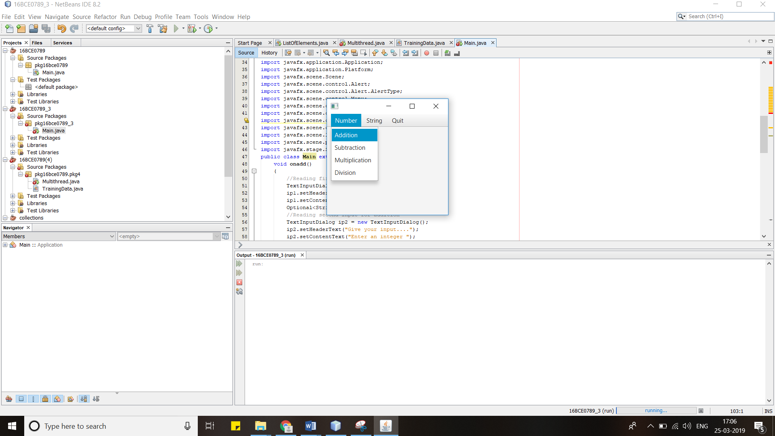

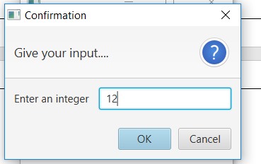

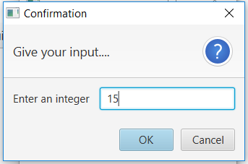

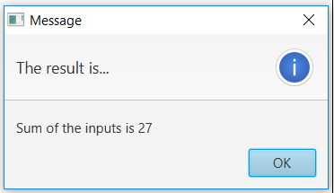

Similarly for Subtraction, Multiplication and Division.

**The Subtraction:**

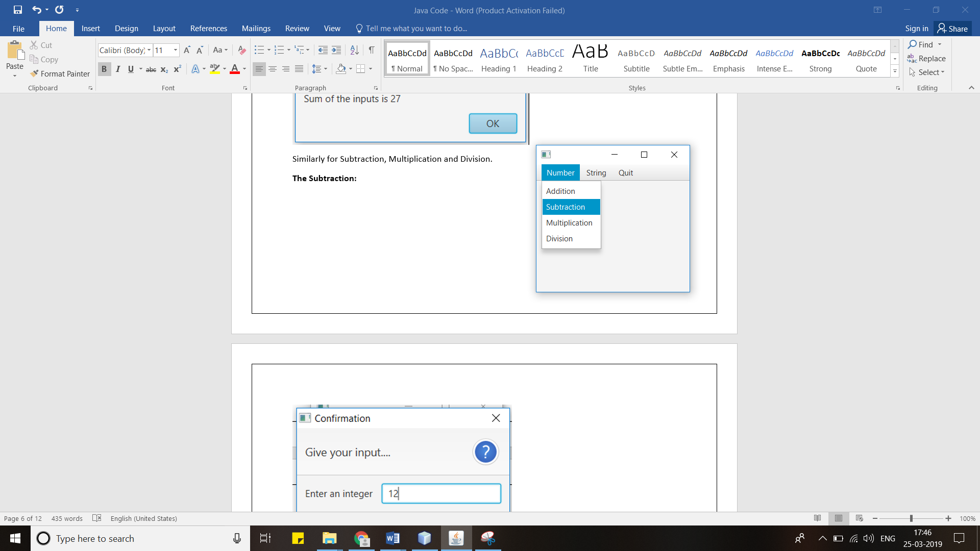





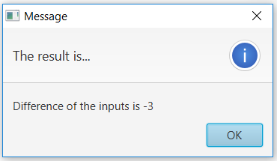

**The Multiplication**

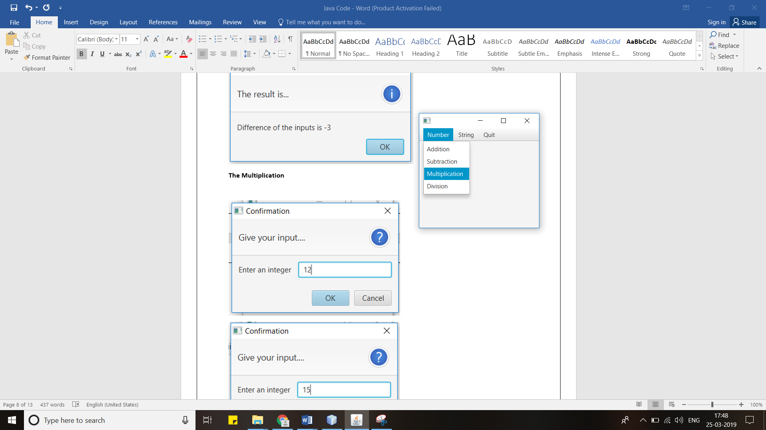





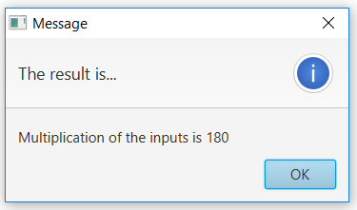

**The Division**

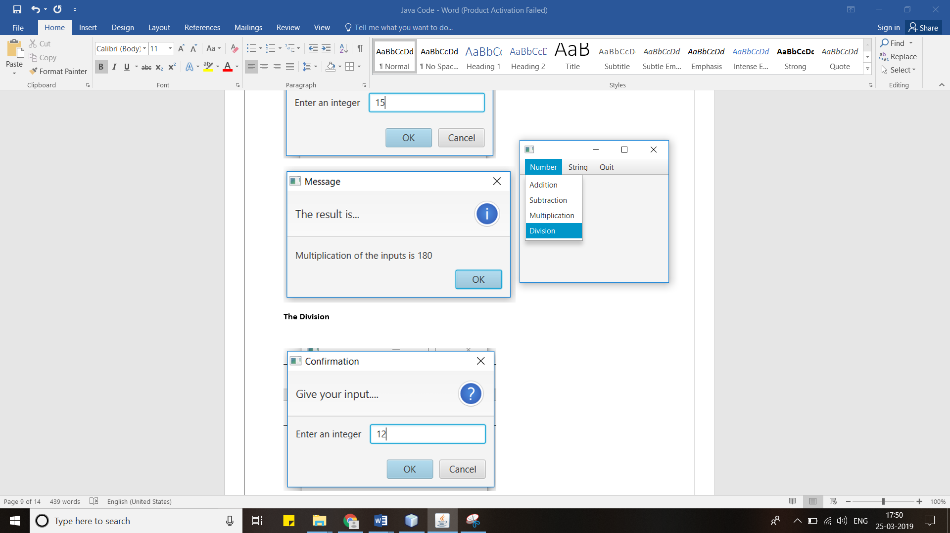



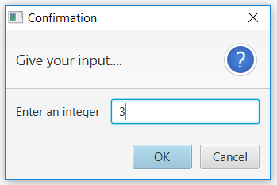

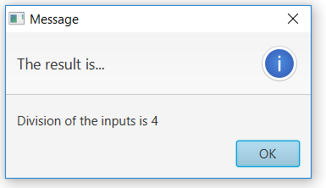

**For Strings**

**The Copying**

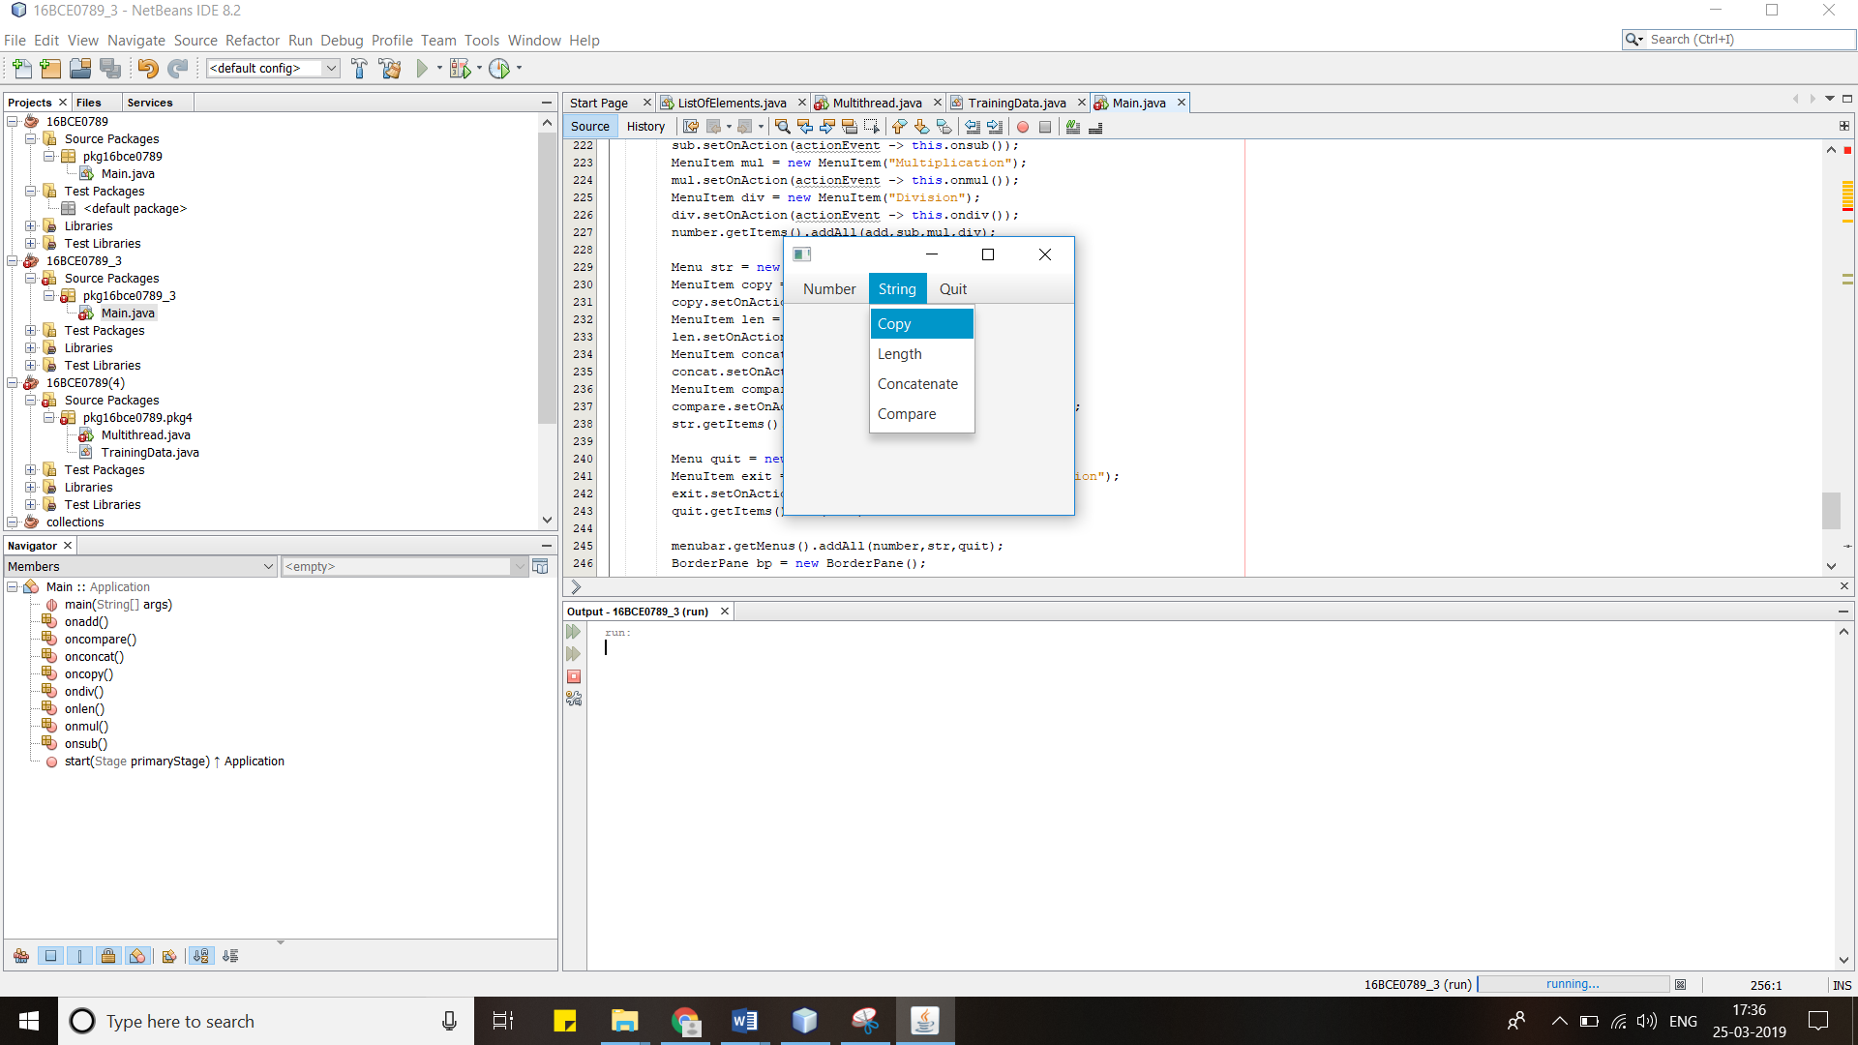

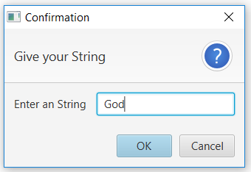

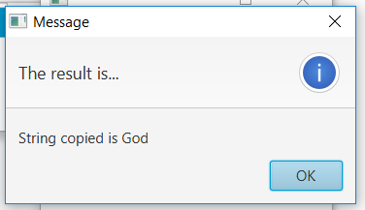

**The Length**

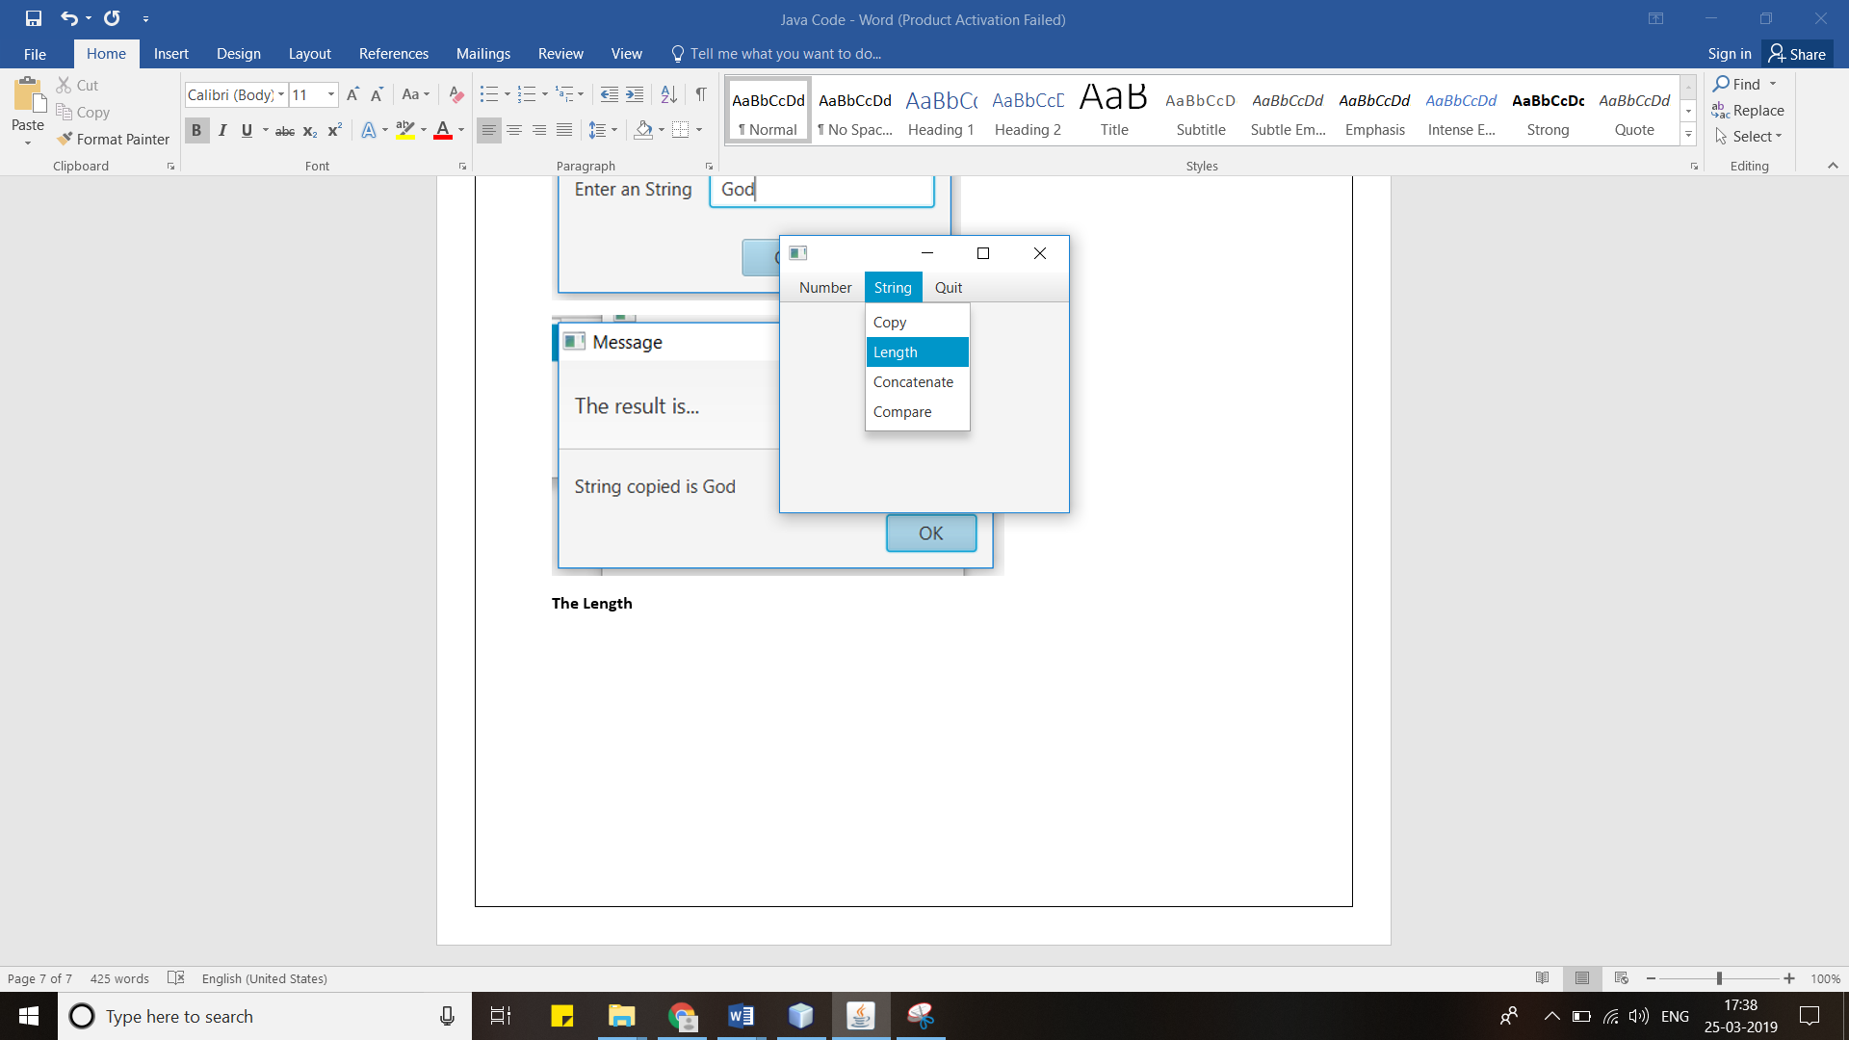

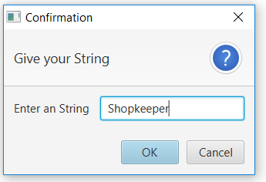

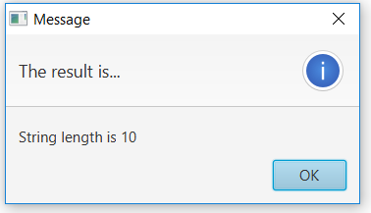

**The Concatenation**

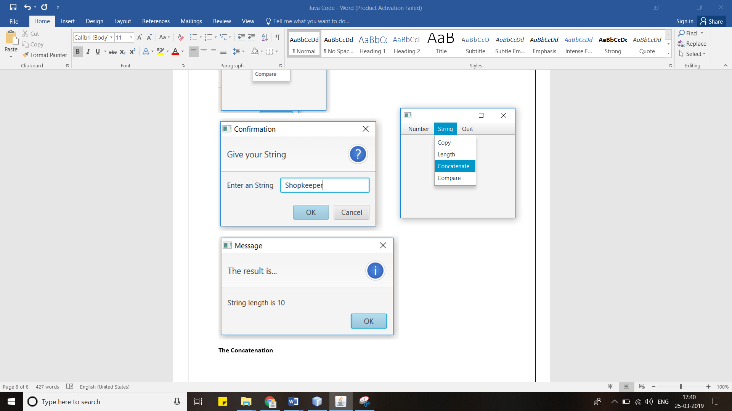

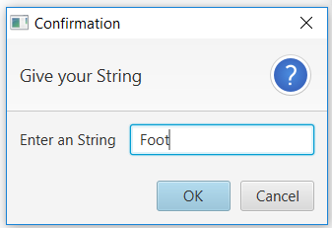

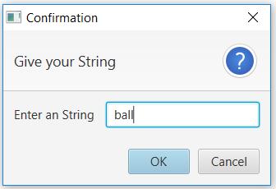

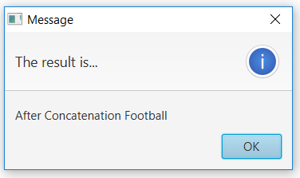

**The Comparing**

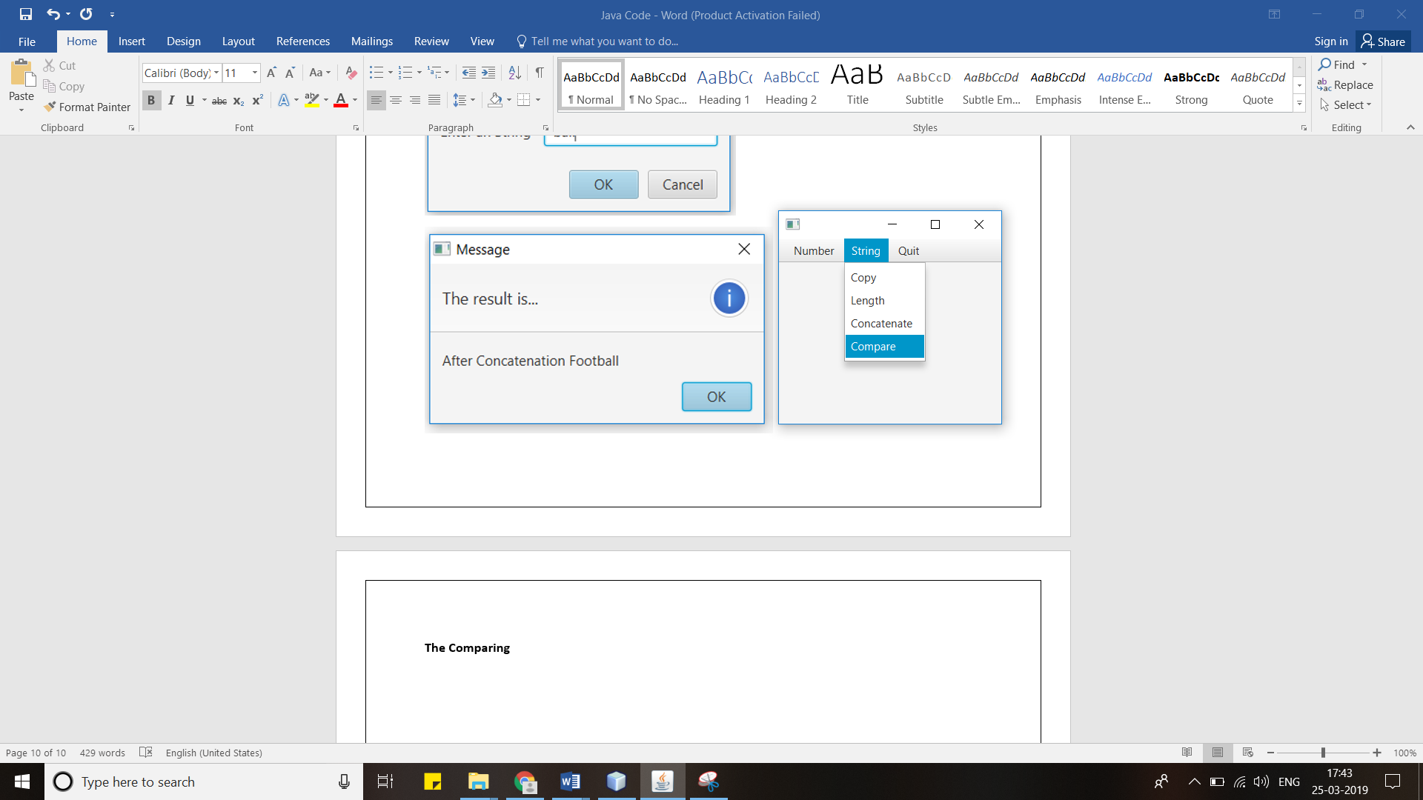

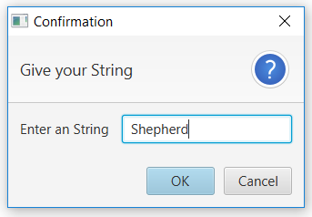

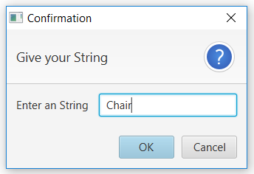

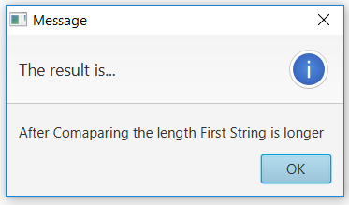

**The Quitting**

